**Hurricane Matthew Media Coverage Oct. 12**

**2,428 News Results**

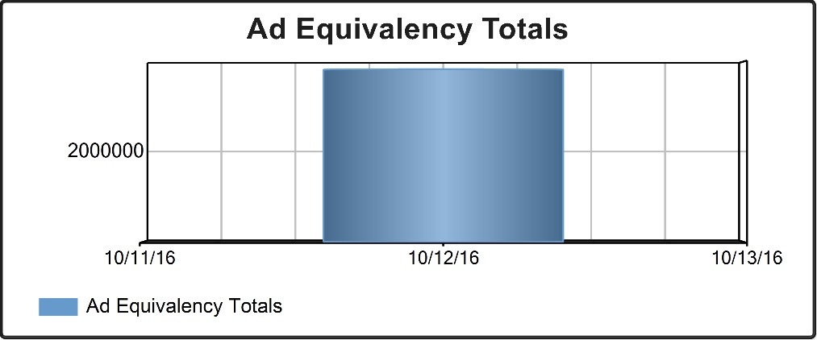

**Oct. 12 - $3,820,144.10**

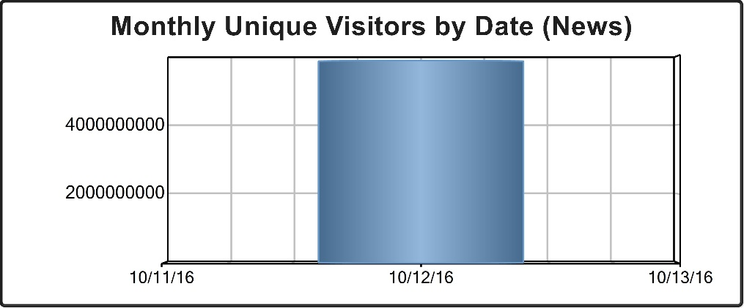

**Oct. 12 – 5,848,881,214**

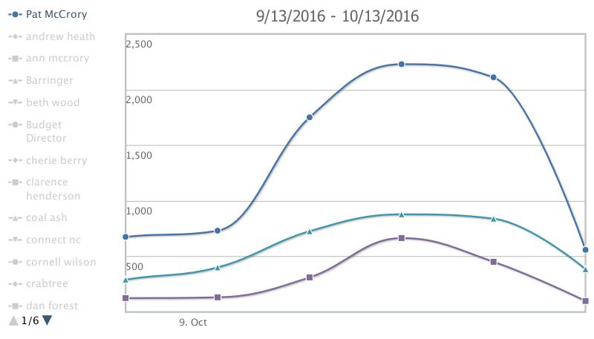

**TV Eyes Mentions: 3,400**